EXPERIMENT 01
TITLE: Installation of Hypervisors and Initiation of VMs with image file.

AIM:
Install and configure an open-source hypervisor and create/instantiate a Virtual Machine (VM) using an existing image file. Demonstrate the successful installation and execution of the VM.
SOFTWARE USED:
1. Oracle VirtualBox 7.2.16 (Open-source Type-2 Hypervisor)
2. Ubuntu 22.04 LTS ISO image file
THEORY:
Hypervisor is a software that creates and runs Virtual Machines. VirtualBox is a Type-2 hypervisor which runs on host OS. VM uses virtual CPU, RAM, Storage and Network from host machine. ISO file contains the Guest OS installer.
PROCEDURE:
Task 1: Install Oracle VirtualBox
Downloaded from http://virtualbox.org and installed on Windows 11 host.
Task 2: Obtain VM image/ISO file
Downloaded http://ubuntu-22.04.iso (3.5 GB).
Task 3 & 4: Create and Configure new VM
New -> Name: Ubuntu-VM -> Type: Linux -> Version: Ubuntu 64-bit
Configuration: CPU: 2 Cores, RAM: 2048 MB, Storage: 20GB VDI Dynamic, Network: NAT
Task 5: Attach the image/ISO file to the VM
Settings -> Storage -> Controller: IDE -> Empty -> Choose Disk -> http://ubuntu-22.04.iso
Task 6: Start and boot the VM
Clicked Start. VM booted from ISO.

Task 7: Complete the guest OS installation
Installed Ubuntu. Created username and password. Ubuntu Desktop appeared.
Task 8: Verify that the VM is running successfully
Ubuntu desktop is running inside VirtualBox window. Verified.
Task 9: Installing required build tools and Linux kernel headers
This step is required to install Guest Additions for full-screen and shared clipboard.
Run these commands in Ubuntu Terminal (Ctrl+Alt+T):
Command 1:
sudo apt update
Command 2:
sudo apt install -y build-essential
sudo apt install -y linux-headers-$(uname -r)
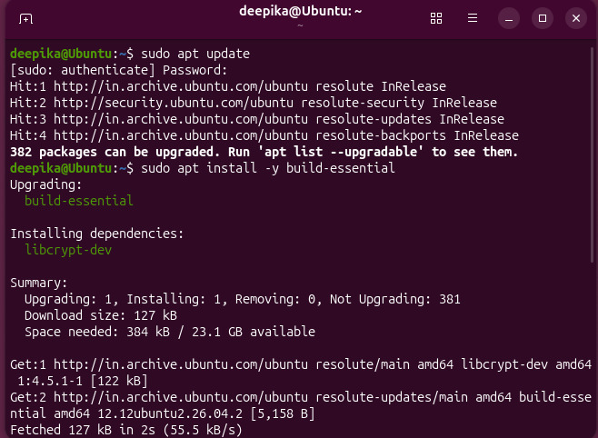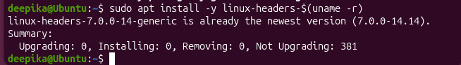
Task 10: Mount Guest Additions and Install
Commands:
sudo mkdir -p /media/cdrom
sudo mount /dev/cdrom /media/cdrom
ls /media/cdrom
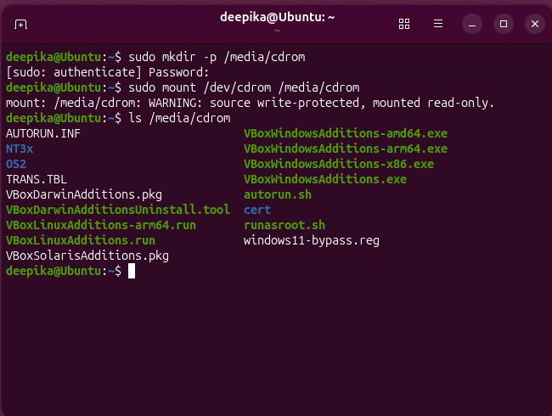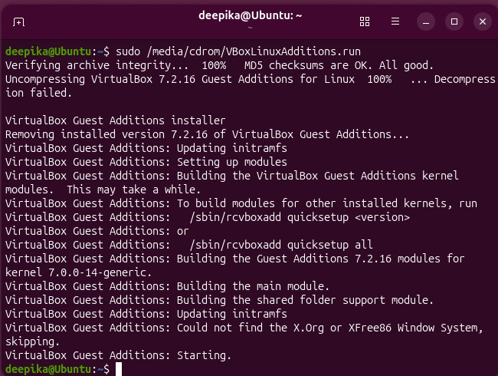

Command:
sudo reboot

RESULT:
Virtual Machine created successfully using Oracle VirtualBox. Ubuntu 22.04 guest OS is running. Required build tools and kernel headers installed and Guest Additions installed successfully for better integration.

CONCLUSION:
In this experiment we learned installation of Type-2 Hypervisor, VM creation with ISO image, configuring CPU/RAM/Storage/Network and installing Guest Additions using linux-headers and build-essential.

